# Fruit Ninja!

# TEAM “Reiko”

## Introduction:

The HTML5 Canvas game “**Fruit Ninja!”** was developed as a team project for the JavaScript IU & DOM course in Telerik Academy. The following description contains information about the contributors, project description and the URL of GitHub Repository.

## http://wac.76ff.edgecastcdn.net/0076FF/hbwebmedia/fn/images/fn/fn-logo.pngContributors:

* Martin Nikolov ([@ flextry](https://github.com/flextry))
* Stilian Kanchev ([@ stiliankanchev](https://github.com/stiliankanchev))
* Daniel Popov ([@ damy90](https://github.com/damy90))
* Stefka Marinova ([@ jibonita](https://github.com/jibonita))
* Kiril Todorov ([@ kirilt7](https://github.com/kirilt7))
* Nevena Angelova ([@ nevena-angelova](https://github.com/nevena-angelova))

## Project Description

**“Fruit Ninja”** is one of the greatest fruit-slicing game in the world. **Fruits** are the targets in Fruit Ninja. You must slice them to earn points.

The game is implemented using HTML5, CSS3, HTML5 Canvas + Animations, JavaScript + OOP, Design Patterns, KineticJS, jQuery, RequireJS, etc.

We followed the best OOP Practices and SOLID + DRY principles. We put efforts to make the code **easy to read, understand and maintain, to ensure correct behavior and to provide simple user interface.**

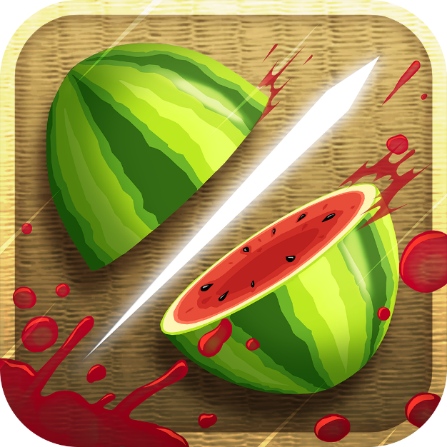

## GitHub Repository

You can find the source code at the following address:

* <https://github.com/Reiko-JS>